Exercise -3

1. Creating a new Repository

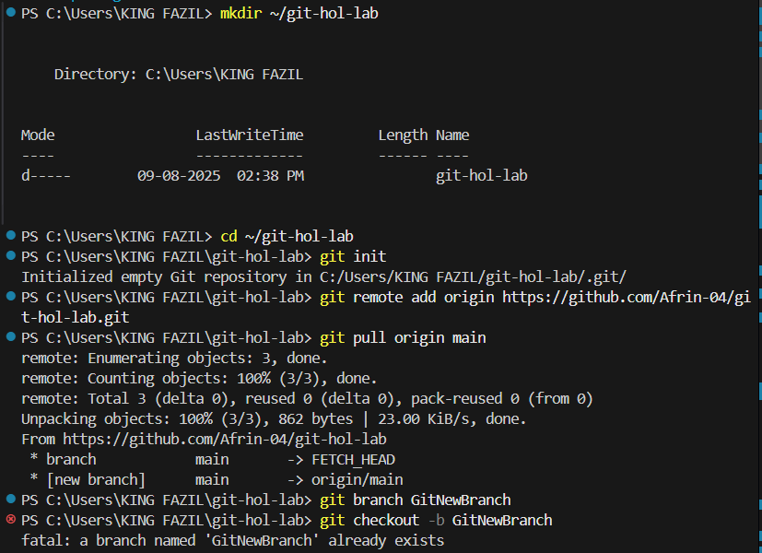

1. Creating a new repository named “GitNewBranch”



1. Creating new files 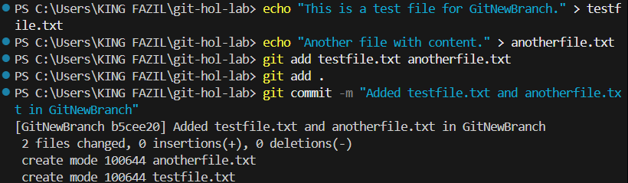
2. Configuring P4Merge

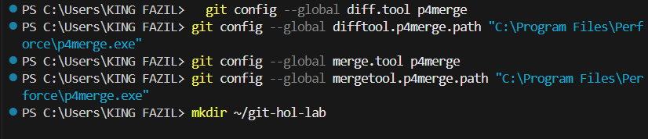

1. Using the tool and merge it

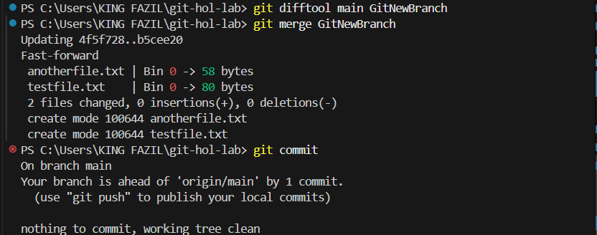

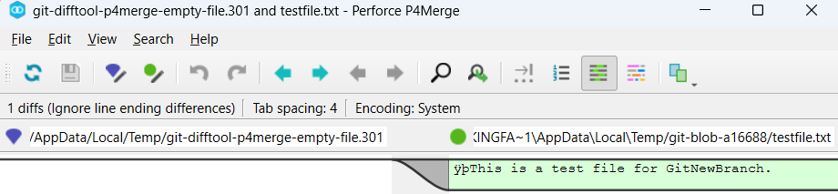

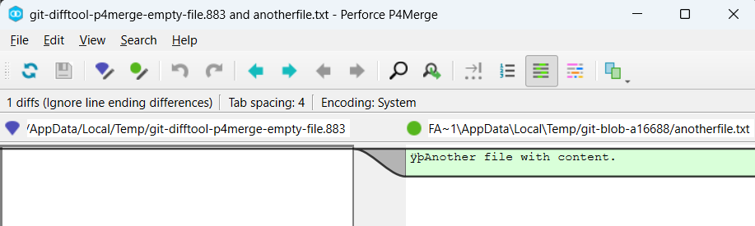

1. After Merging it and checking the gitlog

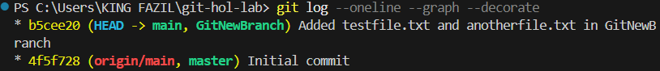

1. Deleting the branch “GitNewBranch”

